Billy DeWolf

Tibetan Fortune Teller Cabinet 32.5” wide X 30” high X 14.5” deep $750

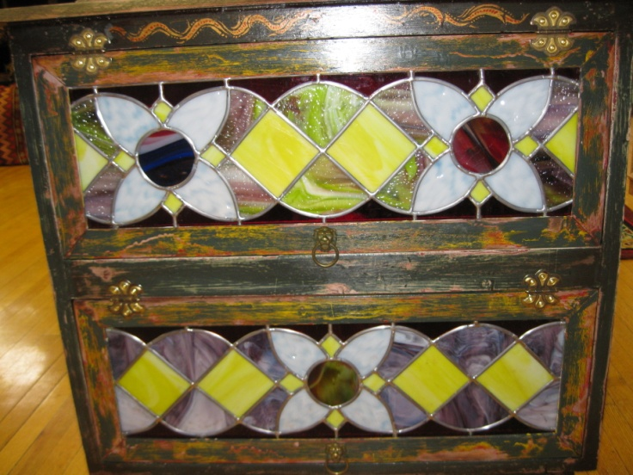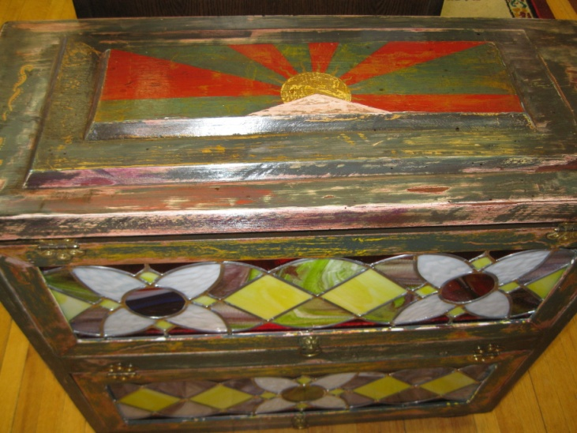

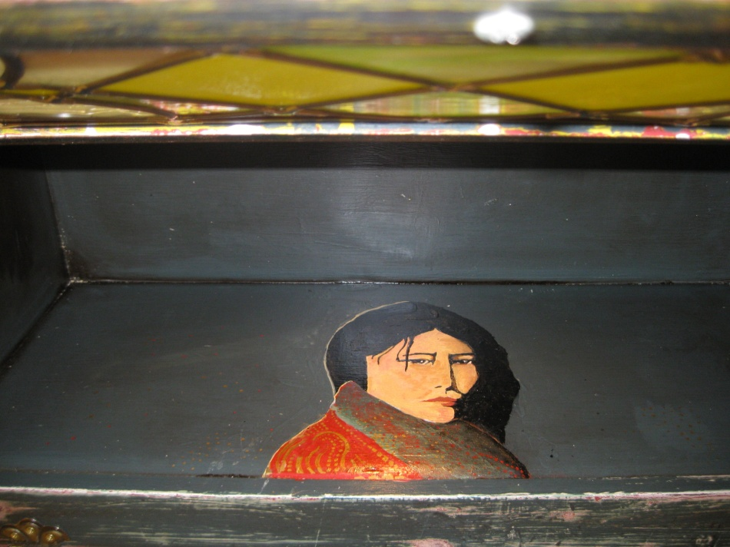
Lit Interior top shelf

